 **ACEC New York Course # 3401**

## CERTIFICATE OF COURSE COMPLETION

### This certifies that has completed

**How to Manage Indoor Air Quality Amid COVID-19**

Mark Drozdov  
**Instructor**  
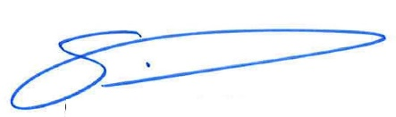

1.0 Professional Development Hours٭٭٭

February 25, 2021

Webinar

*Based on the regulations that govern the certification of coursework in NYS.

٭٭To confirm the acceptance of these PDHs outside of NYS, please consult the licensure board of that state.